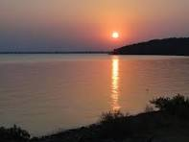 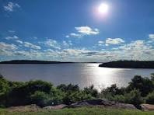 ++


+ 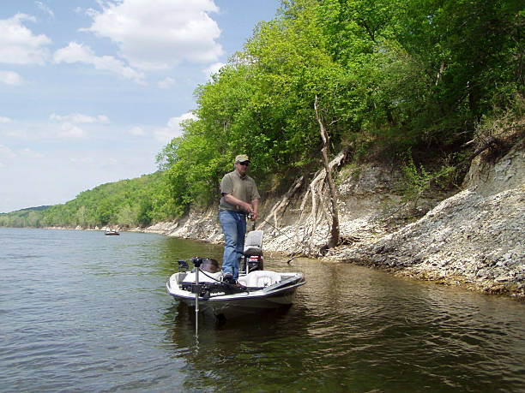
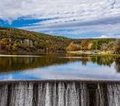 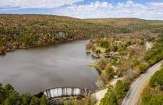 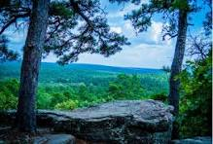 https://www.alamy.com/visitors-explore-the-entrance-of-robbers-cave-at-robbers-cave-state-park-in-wilburton-oklahoma-photo-by-michael-woods-michaelwoodsphotocom-image427079614.html?imageid=0916AF5D-FB21-4A29-907F-88DA1716308F&pn=1&searchId=e8986d7 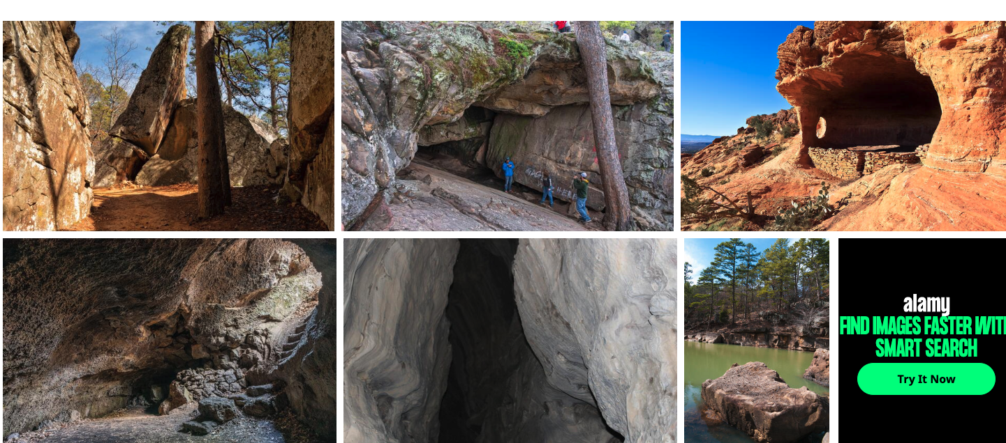2b4946f7575b9a0a35a53d537&searchtype=0+
